../../../../../../var/folders/xq/rdfftznn1hz89h7gdzt2c9vm0000gn/T/com.apple.Preview/com.apple.Preview.PasteboardItems/becoming%20a%20blous%2

**Welcome to BECOMING A BOLUS WIZARD!**

I am excited that you have invested the time to develop your diabetes skills. By the end of this course you will:

**1.** Dominate high glycaemic index meals with new and innovative strategies.

**2.** Have a new set of skills that allow you to be versatile when following different dietary approaches such as when bulking up with higher carb, and leaning down with higher protein.

**3.** Have an in-depth knowledge of how carbohydrate, fat and protein impact your blood glucose level.

**4.** Have the cutting edge knowledge and have more effective bolus strategies than any health care professionals you see.

**5.** Most importantly, YOU WILL BE IN CONTROL.

**How you will become a Bolus Wizard?**

You will not become a Bolus Wizard by just watching the module videos.

**YOU MUST CONVERT YOUR UNDERSTANING INTO LEARNING BY TAKING ACTION.**

I have purposely not included a load of written text content into this workbook. That is because learning is a participation sport, it is YOUR job to:

**1.**Annotate the key diagrams with how you understand it.

**2.** Use the tables to write the key points and then most importantly how YOU are going to take action.

**3.** Document your results and share them with the rest of the Diabetic Muscle and Fitness community in the [Facebook Group](http://www.facebook.com/groups/diabeticmuscleandfitness)

**4.**Share your new knowledge with other Type 1's and your health care professionals.

**How to get the most out this course?**

**1.** Print this workbook and complete the tasks that are discussed in the video.

**2.**Complete the action plans at the end of each module.

**3.** Implement your plans before moving to the next module.

**4.** Document your progress on the [Facebook Group](http://www.facebook.com/groups/diabeticmuscleandfitness)and hit me up with questions and areas where it can be improved.

If you just watch all the videos back to back and do not follow the above points, it's a certainty you are a spectator, and **it's only the participants who learn through action. ENJOY!**

**COURSE CONTENT**

**Module 1 -** Bolus evolution and building a foundation.

**Module2 -** Carb counting: how accurate and how to.

**Module 3 -** Why bolus before a meal and how long before.

**Module 4 -** Super Bolus.

**Module 5 -** Glycemic Index.

**Module 6 -** Personalized Nutrition.

**Module 7 -** When to consider fat and protein.

**Module 8 -** Methods to manage fat & protein—Bell (2015)

**Module 9 -** Alternative methods for fat & protein: FPU&FII.

**Module 10 -** Bolus comparison calculator.

**Module 11 -** Summary and Test.

**Key Resources**

**Module 1**

**Bolus evolution and building a foundation.**

|  |  |  |
| --- | --- | --- |
| **Carbohydrate Technical Name.** | **How quickly does it increase blood glucose.** | **What foods are these found in?** |
|  |  |  |
|  |  |  |
|  |  |  |
|  |  |  |
|  |  |  |
|  |  |  |
|  |  |  |
|  |  |  |

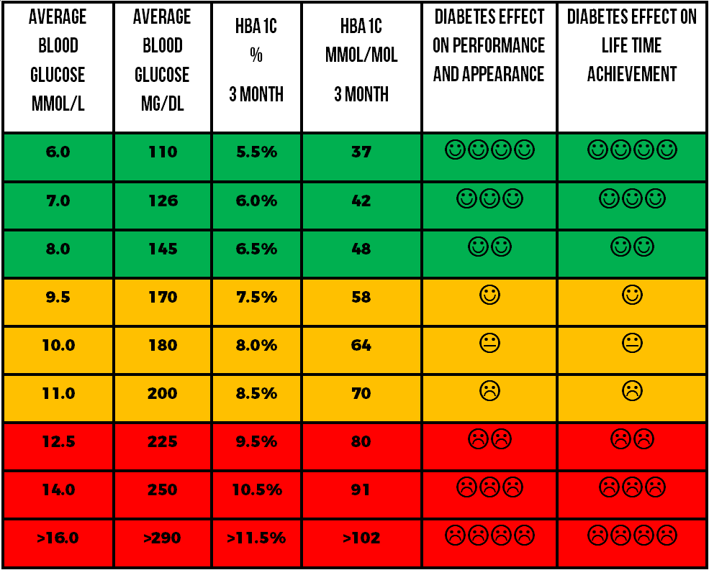

|  |  |
| --- | --- |
| **My key understanding and knowledge points** | **How to apply: Be SMART & Accountable** |
| **1.** |  |
| **2.** |  |
| **3.** |  |

**Module 2**

**Carb counting: how accurate and how to.**

**Equation when weighing foods using European food labels**

Total carb per 100 grams x Your portion grams = Carb grams

100

**Equation when weighing foods using Net carbs from US food labels**

(Total carb - fiber) = Net carb grams x Your portion grams = Carb grams

label portion weight

**APPS that make it simple to count carbs, fat and**

**Protein include; Myfitness Pal and CarbsandCals.**





**Normal mixed macronutrient meals need a carb counting accuracy within 10g.**

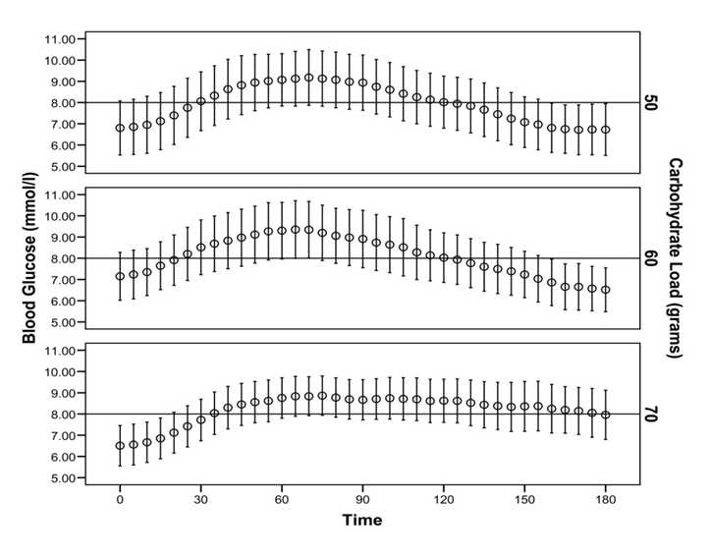

|  |  |
| --- | --- |
| **My key understanding and knowledge points** | **How to apply: Be SMART & Accountable** |
| **1.** |  |
| **2.** |  |
| **3.** |  |

**Module 3**

**Why bolus before a meal & how long before.**

|  |  |  |
| --- | --- | --- |
| **Glucose Level**  **MMOL/L** | **Glucose Level**  **MG/DL** | **Minutes to bolus before meal** |
| 4-6 | 70-100 | 5-15 minutes |
| 6-10 | 100-180 | 15-30 minutes |
| 10-14 | 180-250 | 30-40 minutes |
| More than 14 | More than 250 | 40-60 minutes |

**Blood Insulin Fifteen Food (BIFF)**

|  |  |
| --- | --- |
| **My key understanding and knowledge points** | **How to apply: Be SMART & Accountable** |
| **1.** |  |
| **2.** |  |
| **3.** |  |

**Module 4**

**Super bolus for pump therapy.**

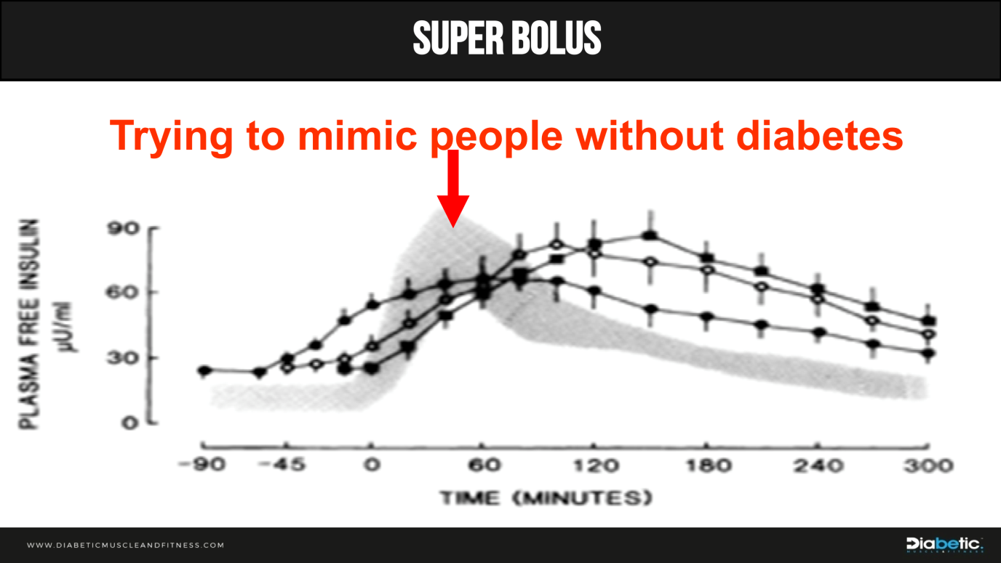

**Two steps**

1. Temporary basal rate of 0% for 2-3 hours just before eating.
2. Add missed basal onto food bolus.

**Example**

* Basal rate 1unit/hr therefore 2-3units of missed basal.
* 100g carb with 1unit:10g =10units
* Total 10 + 2 or 3 = 12 or 13 units

|  |  |
| --- | --- |
| **My key understanding and knowledge points** | **How to apply: Be SMART & Accountable** |
| **1.** |  |
| **2.** |  |
| **3.** |  |

**Module 5**

**Glycemic index (GI)**

The glucose rise from a carbohydrate food in the two hours after ingestion. A score is given for the food compared to the 100 of glucose or white bread. Foods are classified as:

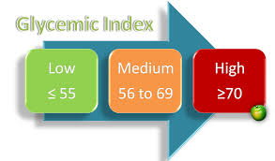

Rapid acting insulin takes about four hours to complete its action. Therefore, lowering the GI helps match the glucose appearance in the blood closer to the insulin action, promoting a lower glucose levels after eating.

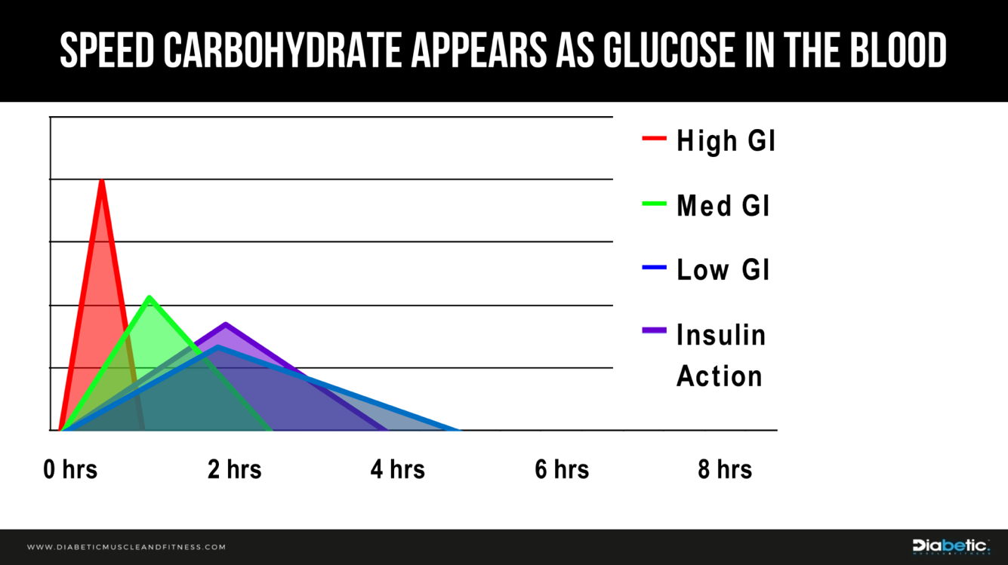

**Ways to lower GI:**

* Fat and protein in foods slows digestion. Egg on toast vs. Toast with jam.
* Fibre in foods makes digesting carbohydrate more difficult and slow. Whole grain vs. White processed.
* Type of carbohydrate structure: Amylose vs. Amylopectin vs. Oligosaccharides.
* Less processed carbohydrateis harder to digest e.g. Whole fruit vs. fruit juice

**SIMPLE AND EFFECTIVE SWAPS**

|  |  |  |  |
| --- | --- | --- | --- |
| **Food** | **Low GI** | **Medium GI** | **High GI** |
| **Bread** | Multigrain eg. granary | Crumpets, Pitta bread | All wholemeal, brown, white inc.French bread, naan |
| **Breakfast cereals** | All Bran, Special K,  Porridge | Weetabix, Alpen | Cornflakes, Bran flakes, Rice Krispies |
| **Potatoes** | Sweet potato, yam | New potatoes, crisps, French fries | Old potatoes – boiled, baked, roast, mashed |
| **Pasta and Rice** | Pasta – all types, basmati rice | Couscous | White rice, tapioca |
| **Vegetables** | Pulses eg lentils, baked beans, sweetcorn |  |  |
| **Fruit** | Apples, Oranges, Bananas | Dried fruits | Watermelon, Dates |
| **Dairy Produce** | All milk products  Yogurt |  |  |

|  |  |
| --- | --- |
| **My key understanding and knowledge points** | **How to apply: Be SMART & Accountable** |
| **1.** |  |
| **2.** |  |
| **3.** |  |

**Module 6**

**Personalised nutrition**

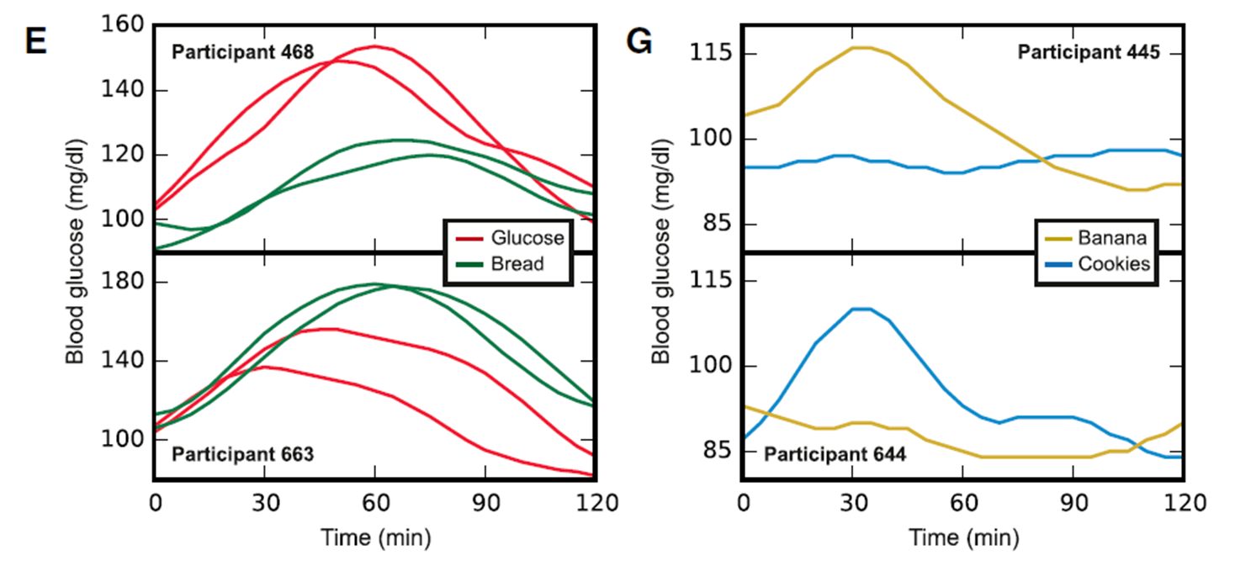

**Module 7:**When to consider fat and protein.

**Module 8:**Methods to manage fat & protein—Bell (2015)

|  |  |
| --- | --- |
| **My key understanding and knowledge points** | **How to apply: Be SMART & Accountable** |
| **1.** |  |
| **2.** |  |
| **3.** |  |

**Module 7**

**when to consider fat and protein**

**Why do some foods digest slower and need more insulin (see diagram on the next page)?**

**High protein intake:**

* Increases GIP (Gastric Inhibitory Polypeptide) which increases Glucagon secretion from the Alpha cells of the pancreas. The increase in Glucagon elevates liver output of glucose in two phases, early and late digestion:
  + Early digestion by breaking down liver glycogen to liberate glucose (liver glycogenolysis).
  + Late digestion by creating new glucose from the excess amino acids from protein digestion (Gluconeogenisis).

**High fat Intake:**

* Slows down gastric emptying by increasing GLP-1 (Glucagon-Like-Peptide-1) output from the intestines. The increase GLP-1 feeds back to the stomach to slow emptying. This slows the appearance of glucose in the bloodstream.
* Causes insulin resistance at the cell level, not allowing insulin to open the cell door to allow glucose to move in effectively. More insulin is needed to overcome this resistance at the cell level.

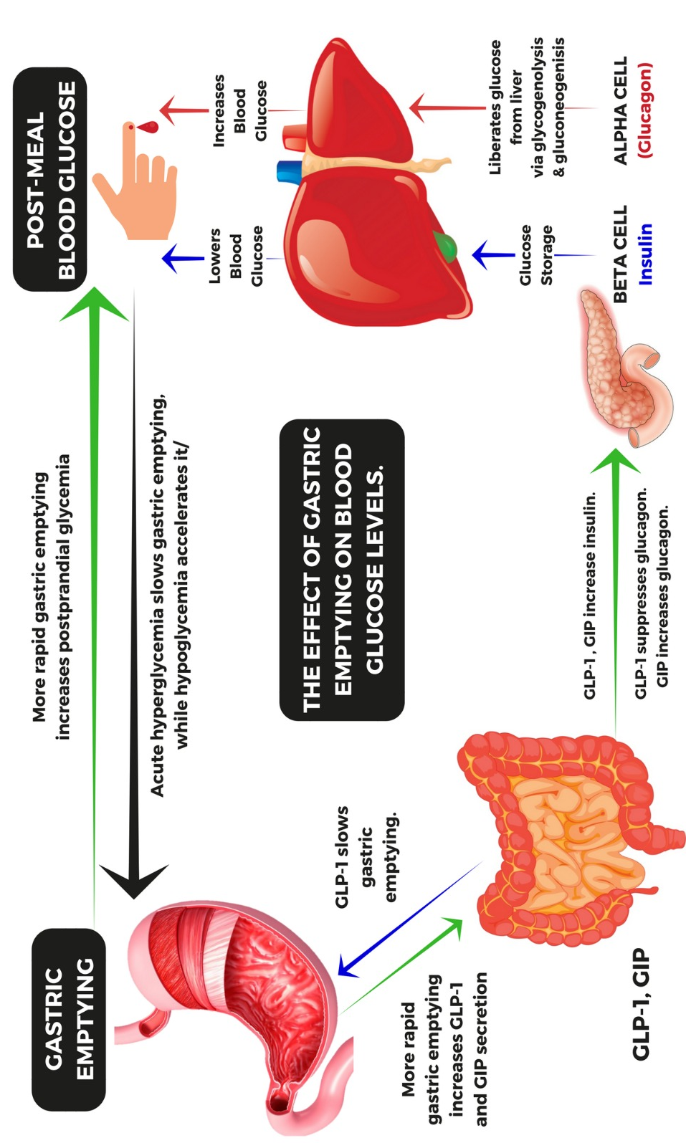

|  |  |
| --- | --- |
| **My key understanding and knowledge points** | **How to apply: Be SMART & Accountable** |
| **1** |  |
| **2.** |  |
| **3.** |  |

**Module 8**

**methods to manage fat and protein**

**(bell 2015)**

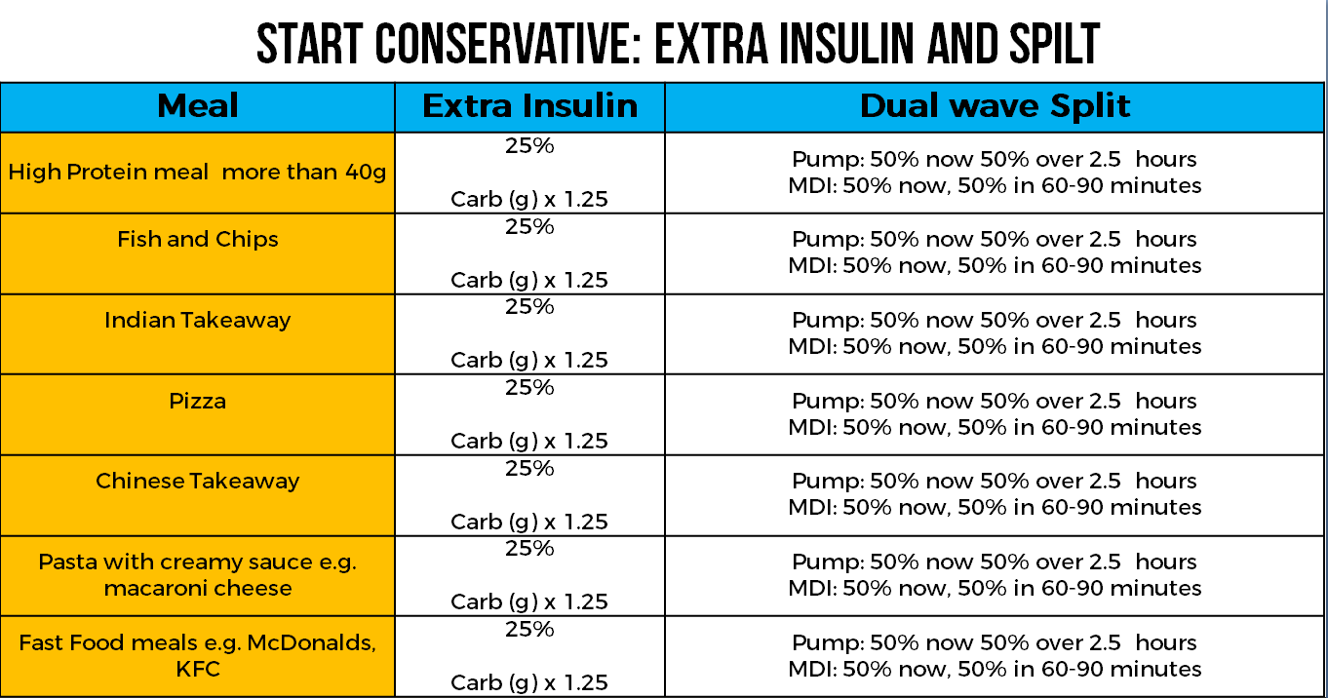

**Monitoring:**

* Test blood glucose before meal.
* Test blood glucose two half hours after.
* Test blood glucose six hours after.

**Two half hour test.**

**Does the first percentage split need adjusting?**

If blood glucose more than 4mmol/l (70mg/dl) higher than before meal:

* Increase the initial % by 20%
* e.g. 50% + 50% **to** 70% + 30%

If blood glucose lower than before meal blood glucose:

* Reduce the initial % by 20%
* e.g. 50% + 50% **to** 30% + 30%

**Six-hour test. Do you need more insulin?**

If blood glucose at six hours is 2 – 6 mmol/l (35 - 100mg/dl) higher than before meal:

* Increase the additional carbs by 10%, so from 25% extra to 35% extra.
* Carbohydrate to be eaten x 1.35
* E.g. 100 x 1.35 = 135g

If blood glucose at six hours is more than 6 mmol/l (110mg/dl) higher than before meal:

* Increase the additional carbs by 20%, so from 25% extra to 45% extra.
* Carbohydrate to be eaten x 1.45
* E.g. 100 x 1.45 = 145g

|  |  |
| --- | --- |
| **My key understanding and knowledge points** | **How to apply: Be SMART & Accountable** |
| **1.** |  |
| **2.** |  |
| **3** |  |

**Module 9**

**Alternative methods for fat & protein**

**(FPU&FII.)**

**How many units using the different methods?**

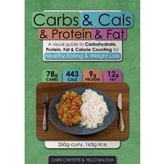

Using the Carbs &Cals cover example see the difference between:

**1.** Carb counting

**2.** FPU method

**3.** FII Extrapolation

**Carb ratio of 1u:10g**

**If only for carbs = 3.6units**

**FPU = 7.6units total**

3.6units for carbs + 4units FPU (260kcal protein + 135kcal fat = 395kcal)

Dual wave of 8hours or second injection after 4 hours!

**FII Extrapolation (count 50% of protein) = 6.8units**

3.6 units for carbs +3.2units for protein (65 /2)

**Food insulin index (FII) - extrapolation**

**Carbohydrate grams + half protein grams**

**=**

**grams to apply your carb ratio to…**

For person with a carb ratio of 15, eating a 50g carb and 30g protein meal:

50 + (30 x 0.5) / 15 = 4.40units

Make it simple by just add half of the protein grams to the carbs then determine the bolus.

**Ketogenic Diet**

**Carbohydrate grams + quarter protein grams**

**=**

**grams to apply your carb ratio to…**

For person with a carb ratio of 15, eating a 15g carb and 30g protein meal:

15 + (30 x 0.25) / 15 = 1.5units

Make it simple by just add quarter of the protein grams to the carbs then determine the bolus.

|  |  |
| --- | --- |
| **My key understanding and knowledge points** | **How to apply: Be SMART & Accountable** |
| **1.** |  |
| **2.** |  |
| **3.** |  |

**Module 10**

**bolus comparison calculator**

|  |  |
| --- | --- |
| **My key understanding and knowledge points** | **How to apply: Be SMART & Accountable** |
| **1.** |  |
| **2.** |  |
| **3.** |  |

**Module 11**

**summary**

* **Carb counting**

- Applying your carb ratio to ONLY the grams of carbohydrateworks, IF you keep a consistent mixed macronutrient profile.

* 40-60%carb 20-30% protein, 20-30% fat.
* It does not work effectively when fat and protein are increased significantly.
* It does not work when leaning down and you go lower carb and higher protein.
* **Stopping highs immediately after meals**
* Bolus pre-meal 15-30 minutes.
* Super bolus if on pump.
* BIFF.
* **Lower GI**
* Good principal to follow.
* Promotes real food.
* Careful with mixed messages.
* **Personalized Nutrition**
* You have the glucose monitoring tools.
* **Bulking or maintenance.**
* Mixed macronutrient meals just need carb ration (40-50% carb, 20-30% protein, 20-30% fat).
* Higher fat and/or protein meals need extra insulin.
* Start with 25% extra and dual wave or split injection.
* **Leaning**
* Low carb / high protein diet (50% protein, 20-30% carb, 20-30% fat)
* Try counting half of protein grams and add to carbs for bolus insulin.
* **Ketogenic**
* <50g carbohydrate, 1.2-2.0g/kg (0.6-1.0g/lb) LBM protein, 70-80% fat)
* Try counting quarter of protein grams and add to carbs
* Trade off of performance for intense exercise.

|  |  |
| --- | --- |
| **My key understanding and knowledge points** | **How to apply: Be SMART & Accountable** |
| **1.** |  |
| **2.** |  |
| **3.** |  |

**What did you score out of 25 on the test?**

Post your results, learning and experience on the[**FACEBOOK GROUP.**](http://www.facebook.com/groups/diabeticmuscleandfitness)

**Key Resources**

1. [The Diabetes and Muscle Fitness Guide](https://diabeticmuscleandfitness.com/the-diabetic-muscle-and-fitness-guide-book/).
2. **The Diabetic and Muscle Fitness BolusWizard Calculator**(found within this module)

**References**

* **Bell (2015) Paper -** <http://care.diabetesjournals.org/content/diacare/38/6/1008.full.pdf>
* **Marty Kendal (2015) - How to calculate the insulin load of food -** [https://optimisingnutrition.files.wordpress.com/2017/01/optimising-nutrition-managing-insulin-v3.pdf](https://optimisingnutrition.files.wordpress.com/2017/01/optimising-nutrition-managing-insulin-v3.pdf%20)

**Coaching**

Get in the best shape of your life, for the rest of your life — with help from our world-class coaching team. It’s time to take control of your health and get the body you’ve always wanted. You can learn more and reach out to us on the coaching page.

**Other Diabetes Management Courses available on the Diabetic Muscle and Fitness Members Site.**

* **Managing Exercise for type 1 Diabetes**: Cutting edge evidence base grounded in thousands of hours of clinical practice to produce the ***Brand New Exercise Calculator, to put you in CONTROL*** of making effective exercise plans.
* **How to optimize diabetes control using Continuous Glucose Monitoring (CGM)**: Real life experience combined with the latest evidence to create ***Breakthrough Tools that allow you to get the MAXIMUM BENEFIT*** from CGM.